**Angular Forms & Related Properties**

**Reactive form:**

**html**

**Ts file**

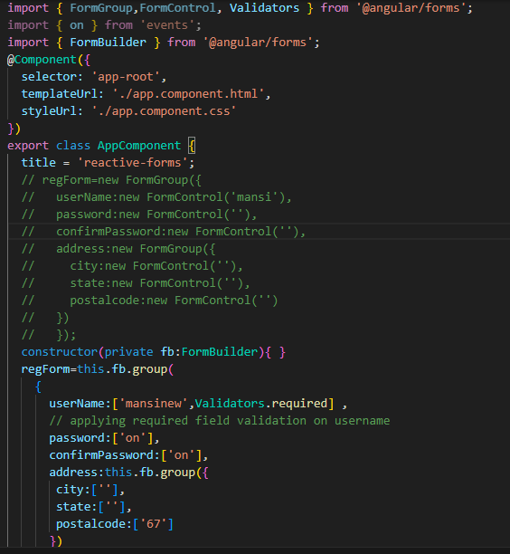

**Also worked with template driven form:**

**Some glimpses from vs code files implemented by me:**

**Pipes**

